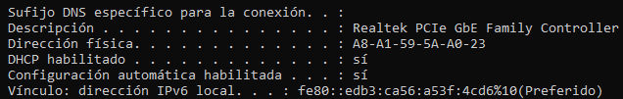

a=10

b=11

c=12

d=13

e=14

f=15

IPv6

fe80= 0+128+3584+61440=65152

edb3=3+176+3328+57344=60851

ca56=6+80+2560+49152=51798

a53f=15+48+1280+40960=42303

4cd6=6+208+3072+16384=19670

IP en decimal=65.152.60.851.51.798.42.303.19.670

MAC

A8=10100110

A1=10100001

59=01011001

A0=10100000

23=00100011

MAC en binario=10100110-10100001-01011001-10100000-00100011